Computer Vision HW4

姓名:胡嘉祐 學號: r07922162 系級：資工碩一

1. Result

1.dilation 2.erosion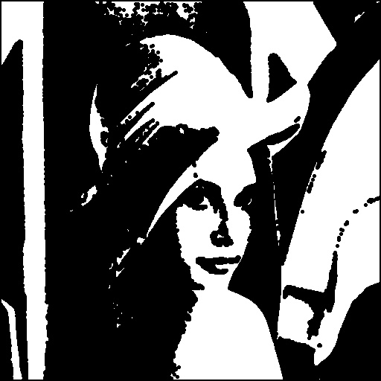

3.opening 4.closing

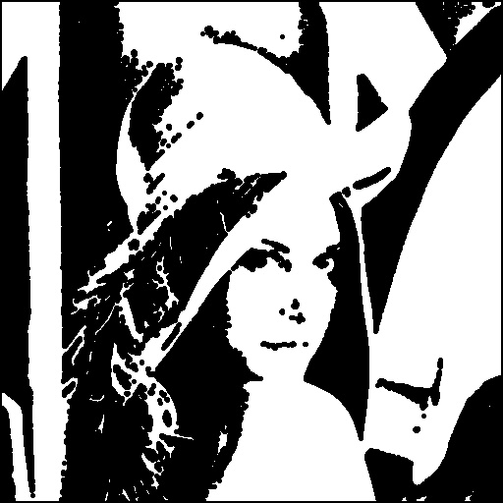

5.hit and miss transform



1. principle code and algorithm

using 3-5-5-5-3 kernel

1. dilation

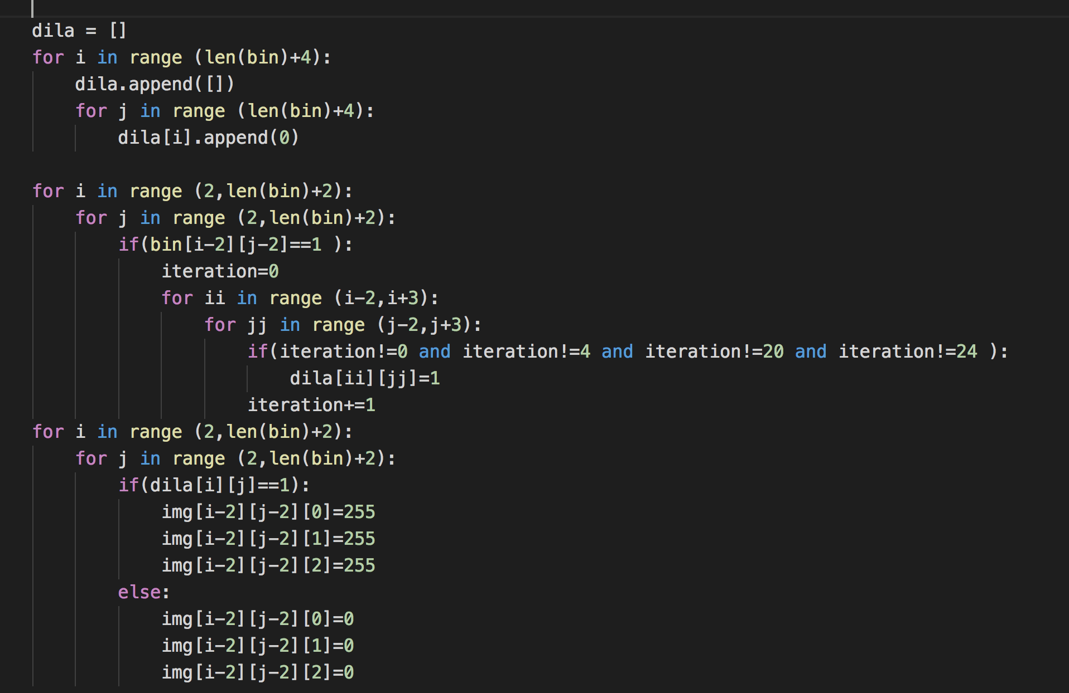

1. erosion

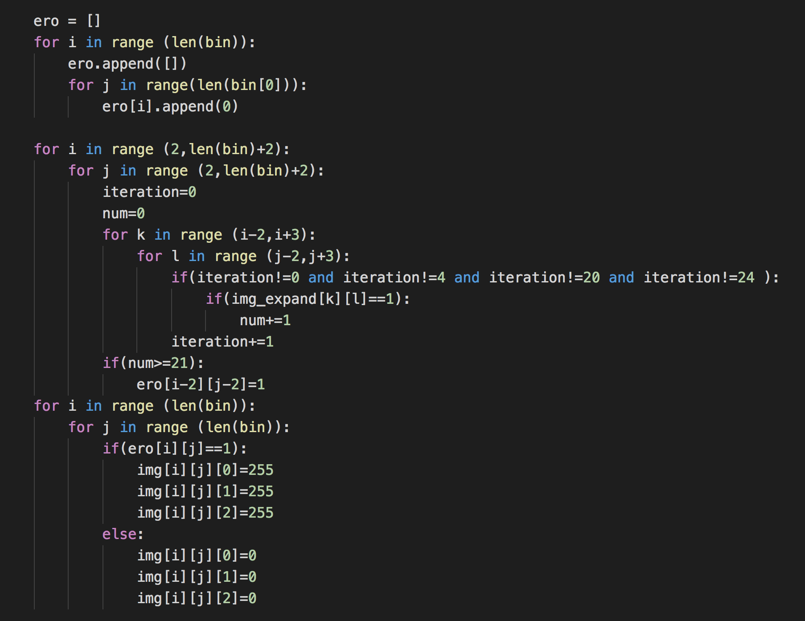

1. opening and closing 使用dilation 加上erosion 即可生成

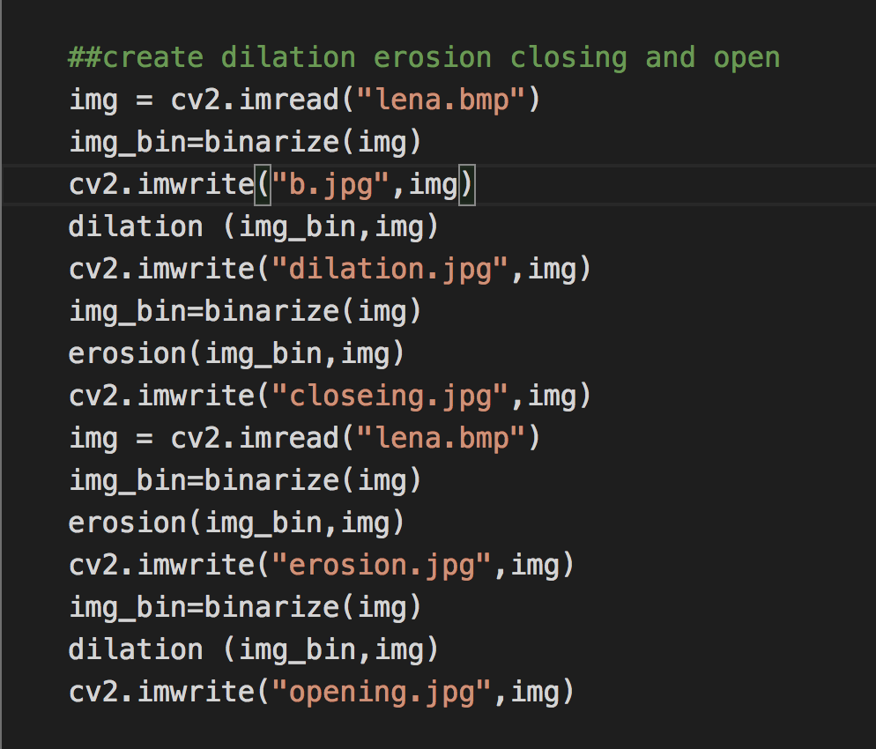

4.hit and miss transform

